**HOTEL MANAGEMENT SYSTEM**

**[JAVA PROJECT] - (OUTPUT PHOTOS):**

**SPLASH SCREEN:**

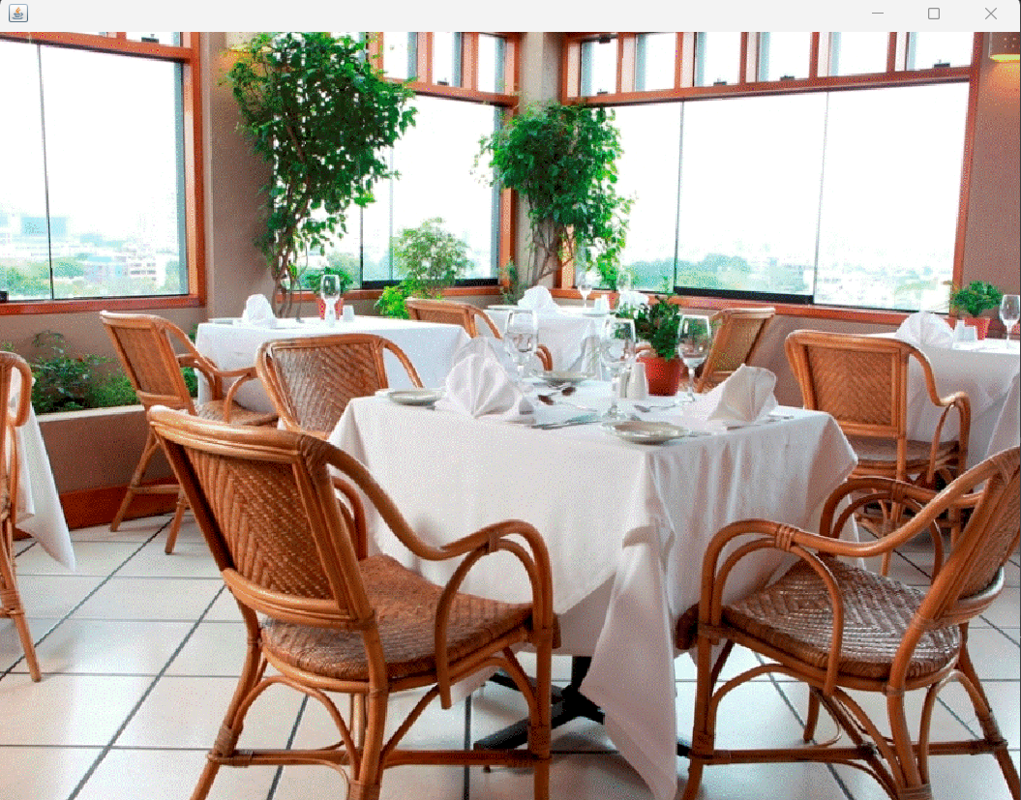

**LOGIN 1 SCREEN:**

**DASHBOARD SCREEN:**

**RECEPTION SCREEN:**

**ROOM SCREEN:**

**DEPARTMENT SCREEN:**

**CHECK OUT SCREEN:**

**UPDATE CHECK IN DETAILS SCREEN:**

**UPDATE ROOM STATUS SCREEN:**

**SEARCH ROOM:**

**LOGIN 2 SCREEN:**

**ADMIN SCREEN:**

**ADD ROOM SCREEN:**

**ADD DRIVER SCREEN:**

